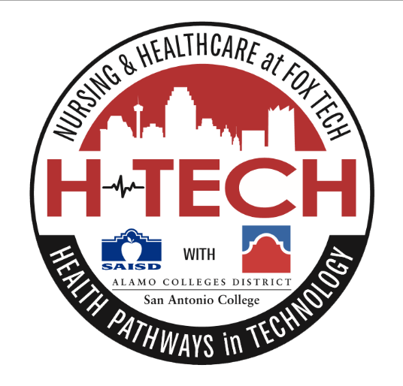

H-TECH Leadership Committee Meeting (Via Zoom)
November 15, 2021
Agenda:
- Welcome & Introductions
- Benchmark 1: School Design
  - Open enrollment lottery system
  - No academic requirements to apply and enroll
  - Goal: to pair students with mentors for real world experiences
    - Volunteer Portal
    - Mentoring Program Playbook
- Benchmark 2: Target Population
  - Current enrollment Cohort 1 (Class of 2024/ 10th grade) = 58 (5 fewer than last year)
  - Current enrollment Cohort 2 (Class of 2025/ 9th grade) = 60
  - Recruitment
    - Choice Recruitment Timeline
    - Installation of banners at high-traffic middle school sites
    - Parent information sessions (both virtual and in person)
    - Seeking 150 for next Cohort
    - Mini fairs
    - Virtual Tour
    - Middle school presentations
    - Yard Signs
    - WOAI Commercial (pending)
    - Health Fairs
    - Social Media
- Benchmark 3: Strategic Alliances
  - Recent conversation with IHE (ACN) for 4-yr. institution Transfer Advising Guide (TAG) alignment- see draft crosswalk
  - Access to college professors proving successful
    - Constant productive communication between College Advisor and PTECH support Teacher for increased student success
  - Increasing Work-Based Learning Mentorship
    - UIW School of Osteopathic Medicine
    - SA 2020
    - Labor on Demand/San Antonio Metro Health Department
    - UIW Pharmacy School
    - Christus Santa Rosa
    - TSAOG

- Benchmark 4: Curriculum, Instruction, & Assessment
  - Adjustments to crosswalk
    - Original crosswalk
    - New draft proposal
      - Addition of Chemistry for additional support
      - Fewer students taking fewer hours freshman year
      - Exit points and options
  - Introduction of Cambridge TSIA 2 prep
    - 1st Cohort-Total enrollment = 55 (down from 66 last year)
        - Speech
        - Art (95% passing)
        - Spanish (100% passing)
        - UT On Ramps Chemistry
        - US History (79% passing)
        - Psychology & Ethics to be added in Spring semester
    - 2nd Cohort - Total enrollment= 60 (50 enrolled in DC courses- 56 at midterm)
        - Art Appreciation (100%)
        - Speech (99% passing)
        - Spanish (75% passing)
- Benchmark 5: Work-Based Learning
    - New team addition: Work-Based Learning Specialist, Mark Vargas, Jr.
    - WBL Calendar
- Benchmark 6: Student Support & Interventions
    - New team addition: P-TECH Support Teacher: Denise Martinez Ruiz
    - Academic Mentoring
      - Weekly grade checks
      - TSI Test prep & Retesting
      - Constant communication with professors and college advisors
      - Ongoing class and degree audits
    - Regularly reoccurring parent nights & office hours after hours
    - SIMS Tutorials
    - Additional supports from SAC student advisor (Crystal Olivo)
    - SAC Tutors
    - C-Days- introducing skills labs to increase engagement and anticipation
    - 7 Habits of Highly Effective Teens (Leader in Me)
    - Parent communication & Home Visits
- Program Needs, Action Items, & Homework
  - Redesignation commitment
  - Recruitment assistance
    - Breakout rooms
  - Next Meeting Thursday, December 16, 2021 @11:00 AM Via Zoom

