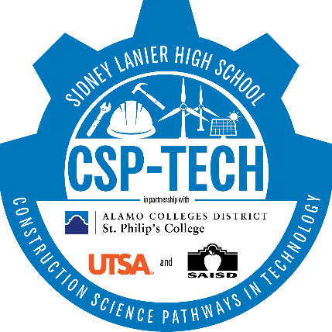
2021-2022
Construction Science P-TECH Bridge Program
Newly-admitted P-TECH students that are entering the Construction Science P-TECH as 9th graders in the Fall of 2021 are required to attend the summer bridge. This provides an academic preparation program with skills necessary for entering high school, college readiness and industry exploration within the P-TECH program. We aim to support our student’s transition by being immersed in the P-TECH culture. Students will earn a minimum of .5 credits for Foundations of Personal Fitness over the summer of 2021.
Week 1 | Monday | Tuesday | Wednesday | Thursday | Friday
Welcome  8:30 - 8:55 | Breakfast in Cafeteria | Breakfast in Cafeteria | Breakfast in Cafeteria | Breakfast in Cafeteria | Breakfast in Cafeteria
Session 1  8:55- 9:55 | Introduction  - Campus scavenger hunt | Field Trip to SPC  - Dual Credit  - Dos/Don’t of college classes  - Access  - Emails  - Grades  - Blackboard  - Campus tour  - ID card  - Orientation?  - Any additional SPC needs | P-TECH Core Activity | TSI Prep English (30-45 min then start test) | PE/Teambuilding
Session 2  10:00 - 10:55 | Introduction to P-TECH  - Pathways  - Certifications  - Data Tracker  - Importance of testing |  | P-TECH Core Activity | TSI Test English | PE/Teambuilding
Session 3  11:00 – 11:55 | Meet the team  - Teachers  - Admin  - Classmates  - Verify classes |  | PE/Teambuilding | TSI Test English | PE/Teambuilding
Lunch  12:00-12:30 | Lunch in the Cafeteria | Lunch in the Cafeteria or Bus | Lunch in the Cafeteria | Lunch in the Cafeteria | Lunch in the Cafeteria
Session 4  12:35 – 1:35 | PE/Teambuilding | PE/Teambuilding | PE/Teambuilding | PE/Teambuilding | PE/Teambuilding
Session 5  1:40 – 2:40 | PE/Teambuilding | PE/Teambuilding | PE/Teambuilding | PE/Teambuilding | PE/Teambuilding
Session 6  2:45 – 3:45 | PE/Teambuilding | PE/Teambuilding | PE/Teambuilding | PE/Teambuilding | PE/Teambuilding
Wrap up  3:45 – 4:00 | Meet in the Cafeteria to debrief | Meet in the Cafeteria to debrief | Meet in the Cafeteria to debrief | Meet in the Cafeteria to debrief | Meet in the Cafeteria to debrief

Week 2 | Monday- Morning rotations | Tuesday- Morning rotations | Wednesday- Morning rotations | Thursday | Friday- Morning rotations
Welcome  8:30 - 8:55 | Breakfast in Cafeteria | Breakfast in Cafeteria | Breakfast in Cafeteria | Breakfast in Cafeteria | Breakfast in Cafeteria
Session 1  8:55- 9:55 | P-TECH Core Activity | P-TECH Core Activity | P-TECH Core Activity | TSI Prep Math (30- 45 min then start test) | P-TECH Core Activity
Session 2  10:00 - 10:55 | P-TECH Core Activity | P-TECH Core Activity | P-TECH Core Activity | TSI Test Math | P-TECH Core Activity
Session 3  11:00 – 11:55 | PE/Teambuilding | PE/Teambuilding | PE/Teambuilding | TSI Test Math | Industry Connections in the Cafeteria  - Meet industry partners  - Goal setting  - Meet mentors  - Lunch together
Lunch  12:00-12:30 | Lunch in the Cafeteria | Lunch in the Cafeteria | Lunch in the Cafeteria | Lunch in the Cafeteria
Session 4  12:35 – 1:35 | PE/Teambuilding | PE/Teambuilding | PE/Teambuilding | PE/Teambuilding | PE/Teambuilding
Session 5  1:40 – 2:40 | PE/Teambuilding | PE/Teambuilding | PE/Teambuilding | PE/Teambuilding | PE/Teambuilding
Session 6  2:45 – 3:45 | PE/Teambuilding | PE/Teambuilding | PE/Teambuilding | PE/Teambuilding | PE/Teambuilding
Wrap up  3:45 – 4:00 | Meet in the Cafeteria to debrief | Meet in the Cafeteria to debrief | Meet in the Cafeteria to debrief | Meet in the Cafeteria to debrief | Meet in the Cafeteria to debrief

