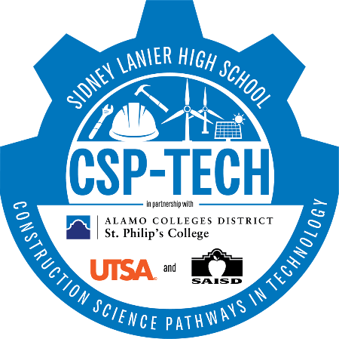

2023-2024 Written Recruitment Plan
August
- Freshmen Orientation
- Meet the VOKS
September
- VOKS Open House
- VOKS Progress Report Night
- P-TECH Ambassadors Program Selection and Training
October
- Visit SAISD Middle Schools to Promote P-TECH Program
- P-TECH Informational Sessions
November
- Visit SAISD Middle Schools to Promote P-TECH Program
- P-TECH Informational Sessions
December
- Visit SAISD Middle Schools to Promote P-TECH Program
- P-TECH Informational Sessions
January
- Visit SAISD Middle Schools to Promote P-TECH Program
- P-TECH Informational Sessions
February
- Visit SAISD Middle Schools to Promote P-TECH Program
- P-TECH Informational Sessions

March
- Begin registration.
- Maintain waiting list and notify parents of enrollment if applicable.
- Facilitate phone calls to homes.
- Send confirmation letters to families and students who enrolled.
April
- Send second communication home with registration deadline.
- Facilitate final reminder calls to families who have not registered yet.
- Notify students who will be mandated to attend Summer Bridge
May
- Share policies, summer bridge and transportation schedule
- Welcome Students to Commitment Ceremony
June
- Call parents of registered students to remind them of the program.
- Make final reminder calls to families prior to the program launch.
July
- Send thank-you letters to students and families.
- Summer Bridge 2023 begins.

