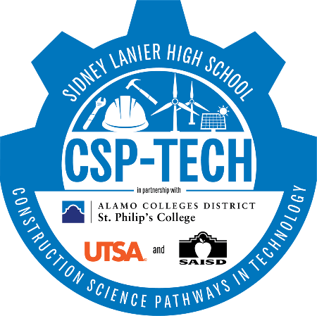

2023-2024 Written Communication Plan

In conjunction with the San Antonio I.S.D. recruitment timeline, Lanier CSP-TECH utilizes the following avenues to communicate with the stakeholders including prospective and current students, parents, community members/partners, San Antonio ISD colleagues, as well Charter and Private Schools within the Bexar County.

- Lanier CSP-TECH website will be the official site for campus news, announcements, important dates, and reference documents. https://schools.saisd.net/page/008.ptech
- Lanier CSP-TECH will utilize social media sites such as Facebook, Instagram, and Twitter to communicate information regarding campus events.
- Lanier CSP-TECH will work closely with the San Antonio ISD Communication Department to ensure accurate information regarding recruitment and application is included on the District website.
- Lanier CSP-TECH will have brochures and marketing materials (English and Spanish) available during all recruiting events.
- Lanier CSP-TECH will reach out directly to middle school counselors and principals to schedule campus visits.
- Lanier CSP-TECH will offer several open house events, during the recruitment season, to inform parents and prospective students about the P‐TECH program. Q&A opportunities and campus tours will also be included.
- Lanier CSP-TECH will recruit students through San Antonio ISD recruitment mini‐fairs, promotional videos, and 8th grade assemblies.
- Lanier CSP-TECH will reach out directly at community events to recruit 8th grade students.

