January 2024 ACME Lesson Plans
Week/Date  01/09-01/12 | TEK/Objective  Activity | Formative Assessment
Week/Date  01/29/24 | Earned Early Release 02/02/24  Please complete with ACME Students on Monday and Tuesday of this week.  Passport Slideshow  Passport PDF Form | 7 Habit Videos- Teacher Skits  Habit 1: Be Proactive Teacher Video: Be Proactive  Habit 2: Start with the End in Mind HABIT 2 Teacher Skit- Begin w the End in Mind  Habit 3: Put First Things FIrst HABIT 3: Teacher Skit- Put First Things FIrst  Habit 4: Think Win-Win HABIT4.MP4  Habit 5: Seek First To Understand, Then be Understood Seek First to Understand, Then to be Understood (1).MP4  Habit 6: Synergize Synergize.MP4  Habit 7: Sharpen the Saw Sharpen the Saw.MP4
Week/Date  01/31/24  Leader in Me | ACME Grade Checks  Please be sure to begin using the ACME Grade Check Forms to check the students grades and meet with them on any failures.  LIM Habit 5 Introduction  Seek First to Understand Then Be Understood  Key message: Empathic Listening is a level above attentive listening. It requires listening not just with ears and eyes, but also with the heart to detect people’s deepest feelings.  Lesson Agenda:  - Watch video - Being Understood  - Discuss the characteristics and traits of persuasive people. Ask: “Who is someone you consider to  be very persuasive? What makes them so persuasive?”  - Discuss the meaning of “good character.” (Having good character means doing the right thing, just because it is right to do.)  - Discuss the connection between high character and high influence.  - Introduce Five-Part Messaging. Project The Five Part Message worksheet  - I saw and heard  - I felt  - I interpreted  - I wanted  - I envisioned  - Have small groups practice Five-Part Messaging. | 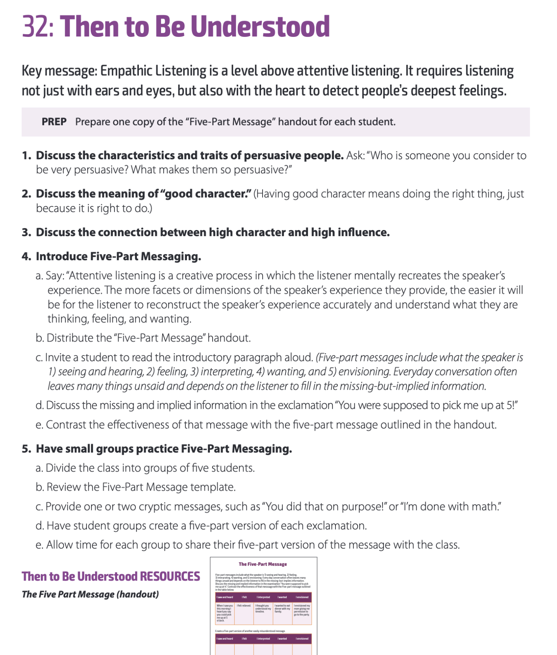

ARCHIVED LESSONS
Week/Date  01/09-01/12 | TEK/Objective  Activity | Formative Assessment
Announcements | Weekly Announcements  01/09-01/12  Please show students the weekly announcements through the link here
1/8/24-1/9/24 | Report Card Pick-Up  Thursday, Jan 11, 2024 at 5 PM  Digital Citizenship Student Lessons Must be complete- this week  Fox Tech DigitalCitizenship 2023-24  Please show students the above slideshow and have students complete all lessons on Slide 3. They must also complete the assessm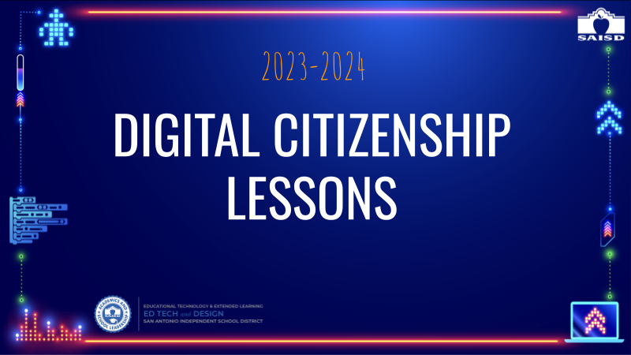ents which will be shown directly after each lesson link on the slide.  Dual Credit Spring Check-In  Please show to students and give them time to check their DC Courses and log-in.
1/10/24-1/11/24  Leader in Me | LIM Habit 5 Introduction  Seek First to Understand Then Be Understood  Key message: People commonly prescribe solutions to problems before making a proper diagnosis. Highly effective people first take the time to deeply understand a problem before offering a solution.  Lesson Agenda:  - Introduce Habit 5 by showing the teacher skit on the right-hand side.  - Introduce the Core Paradigm of Habit 5: “I have more influence with others if I truly understand them first.”  - Discuss: “I diagnose before I prescribe.”  - Show the video Diagnose Before You Prescribe.  - Have small groups discuss one of two Diagnose Before You Prescribe scenarios.  Click the module below for full details regarding lesson  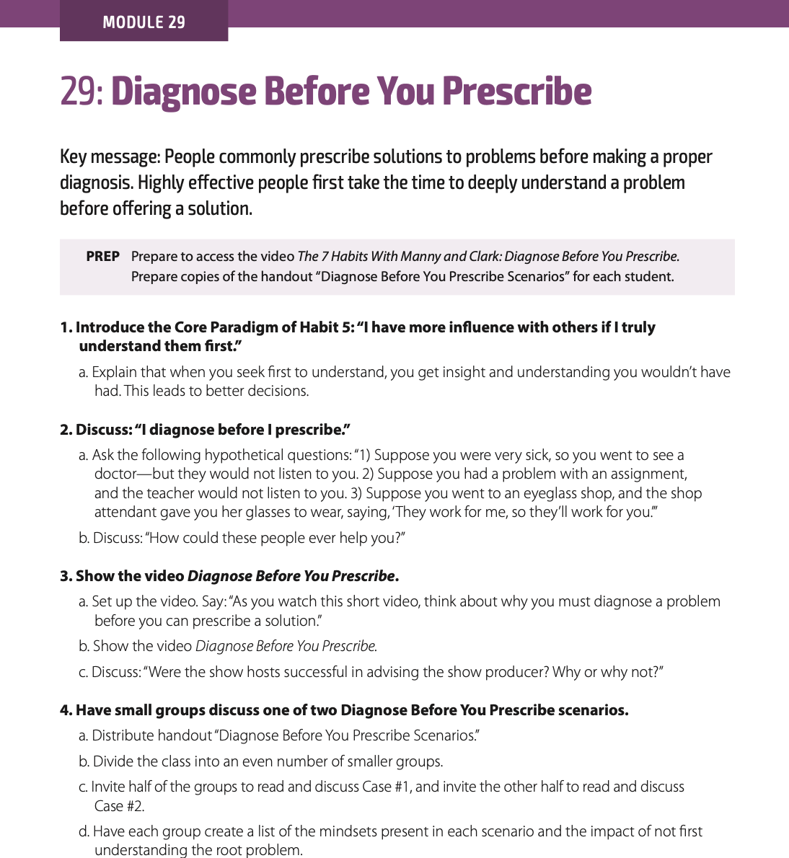 | 7 Habit Videos- Teacher Skits  Habit 1: Be Proactive Teacher Video: Be Proactive  Habit 2: Start with the End in Mind HABIT 2 Teacher Skit- Begin w the End in Mind  Habit 3: Put First Things FIrst HABIT 3: Teacher Skit- Put First Things FIrst  Habit 4: Think Win-Win HABIT4.MP4  Habit 5: Seek First To Understand, Then be Understood Seek First to Understand, Then to be Understood (1).MP4  Habit 6: Synergize Synergize.MP4  Habit 7: Sharpen the Saw Sharpen the Saw.MP4

Week/Date
01/22-01/26
Announcements
Leader in Me | LIM Habit 6 Introduction Synergize  Key message: We live in an interdependent world. This means we depend on others for many aspects of life. In such circumstances, working together is truly better.  Lesson Agenda:  - Play teacher skit  - Introduce Habit 6: Synergize®. Discuss: “How important is synergy?”  - Show the video Synergy.  - Invite small groups to discuss the synergy that occurs with teams.  - Discuss negative synergy.  - Discuss examples of negative synergy in the world.  - Discuss the Ringelmann Effect.  - Discuss the causes of defective teams. | 