Course Name: | AP Capstone Seminar | Teacher: | Mrs. T. Buckley
Year: | 2018-2019 | Email: | Tbuckley1@saisd.net
Course Credit: | 1 CREDIT | Room: | 612
Grade: | 11 | Conference: | 1st period A Days

Course Description https://apcentral.collegeboard.org/courses/ap-seminar/course?course=ap-seminar
Description: Using an inquiry framework, students practice reading and analyzing articles, research studies, and foundational literary and philosophical texts; listening to and viewing speeches, broadcasts, and personal accounts; and experiencing artistic works and performances. Students learn to synthesize information from multiple sources, develop their own perspectives in research based written essays, and design and deliver oral and visual presentations, both individually and as part of a team.
Comment: The overall goal is to prepare students to become effective readers of relevant and valid sources to create a relevant supportive argument. In addition, Students will pass the course. Students must complete acceptable pieces in the following categories: an argumentative writing piece that focusses on the strength of relevant evidence, and a literary analysis that, analyzes the theme of the authors argument and the alignment to thought and process. Writing may also include several open responses and on demand essays. In addition, to receive Advanced Placement credit for the course, students will complete an Individual Research Report of 1200 words, an 8-10 minute Team Research Multimedia Presentation, a 2000 word Individual Written Argument Paper, a 6 to 8 minute Individual Multimedia Presentation, and the AP Capstone End-Of-Course Exam on May 7, 2019.

Course Materials
Each student is required to bring the following materials to class daily:

- Binder (to be kept in class)
- Pens/pencils
- Loose leaf notebook paper

- Agenda/planner (either on paper or electronic)
- Highlighters (at least 4 colors)

Occasionally, non-standard supplies will be required to complete student project deliverables (e.g. poster board, colored paper, etc.).
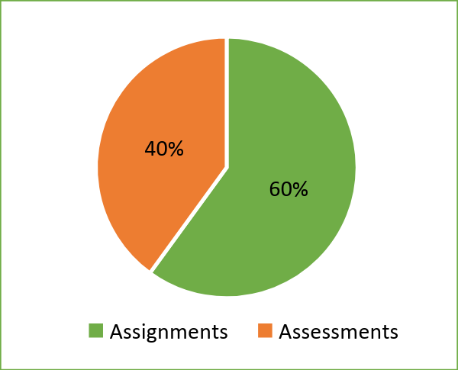

Grading Policy & Scale

Students’ grades will be calculated as follows:
- Assessment Performance (40%)
- Class Work & Homework Performance (60%)

The following grade scale will be utilized for recording students’ grades:
A | 90-100 | In addition to progress
B | 80-89 | reports every three weeks,
C | 75-79 | parents and students have
D | 70-74 | access to iData to monitor
F | 0-69 | grades and attendance.
Ultimately, students are responsible
for their own grades and attendance.

First Semester-Students will be learning and refining skills necessary to achieve success on the AP Seminar Exam. They will be graded based on reading, writing, research and argumentation skills, teamwork and collaboration skills, and presentation skill development. The purpose of the first semester is to develop and strengthen the students’ skills.
Second Semester- Students begin the testing phase of the course. In this phase, I am able to coach the class, but teachers may not give individual feedback to students regarding their work as it is part of the AP Exam. Grading will shift to a 0/50/100 scale. Students will receive a 100 for work turned in on time that meets the criteria of the assignment, a 50 for on time work that does not meet criteria, and a 0 for work that is not turned in.
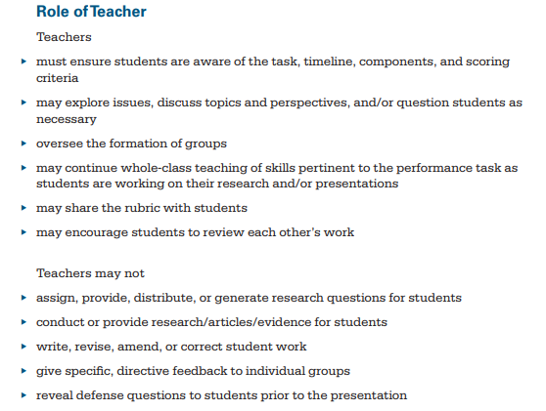

Class Expectations
All students must follow the Hurricane Non-Negotiable Behaviors:
- Be in appropriate school uniform
- Be on time and seated before the tardy bell rings
- Be prepared to learn with heads up and supplies ready
- Use appropriate language at all times
- Keep hands, feet, and other objects to yourself
- Respect others and others’ property
- Keep all electronics turned off and put away

Classroom Management System
CHAMPS: CHAMPS is a proactive and positive classroom management plan that will assist students as they transition through daily class activities by providing specific instruction on expectations. CHAMPS expectations are posted on the classroom whiteboard.
Expectations change to reflect the learning objectives The 5 protocols are:
Conversation: Can students talk to each other during this activity?
Help: How do students get the teacher's attention and their questions answered?
Activity: What is the task/objective? What is the end product?
Movement: Can students move about during this activity?
Participation: How do students show they are fully participating?
Success: When students meet CHAMPS expectations, they will be successful!

Consequences
Students who do not comply with the Hurricane Rules will receive consequences that include, but are not limited to, the following (in no specific order):

- Student/Teacher Conference
- Parent Contact
- Parent/Teacher Conference
- Loss of Classroom Rewards
- Counselor Support
- Discipline Referral

Make-Up Work & Re-Do Policy
The curriculum syllabus and weekly lesson plans will be posted on Google Classroom. Students and parents will have their own user accounts to be able to access the content. Make up work and work needing to be reworked will be available on Google Classroom and will also be offered during my regular tutoring hours or during Saturday School.

Detailed District Policy over make-up work and reworked assignments is clearly outlined in the Student Handbook.

Academic Dishonesty
Students found to have engaged in academic dishonesty shall be subject to grade penalties on assignments or tests and disciplinary penalties in accordance with the Student Code of Conduct. Academic dishonesty includes cheating or copying the work of another student, plagiarism, and unauthorized communication between students during an examination. The determination that a student has engaged in academic dishonesty shall be based on the judgment of the classroom teacher or another supervising professional employee, taking into consideration written materials, observation, or information from students.

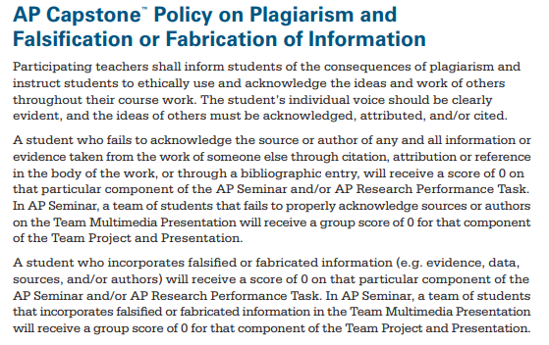

Computer Usage
Computers are to be used for educational purposes only. By touching the computers, students agree to follow the SAISD Student Acceptable Use Policy for the Electronic Communications Systems.

Electronics Policy
Students will not use cell phones or other electronic devices during the school day. Any unauthorized use of cell phones or electronic devices will result in the following:
  - 1st Offense—Review 360 documented verbal warning and reminder that phones will be confiscated and fines assessed.
  - 2nd Offense—Cell phone or electronic device confiscated and returned to parent.
  - 3rd Offense—Cell phone or electronic device confiscated and $10 fine assessed.
  - 4th Offense—Cell phone or electronic device confiscated and $15 fine assessed.

Tardy Policy
The Hurricane Tardy Policy will be strictly enforced. If you arrive late to class, you must have a tardy pass from an administrator.

Dress Code
The SAISD and SHHS dress code will be strictly enforced. If you are not wearing a school uniform, you will not be admitted to class without a note from an administrator. You will be counted absent if you do not return to class that day.

COLOSO Learning Objectives and Gradual Release of Responsibility
COLOSO: This year, ESC 20 is implementing a structure for daily content, language and social objectives (COLOSO). This structure will provide students with a clear focus for daily classroom instruction.
- Content Objective: tells what students will learn during the lesson.
  - Example: “Students will reanalyze archetypes in mythic, traditional, and classic literature.” TEK 2b
- Language Objective: tells how the students will learn and/or demonstrate their mastery of the lesson by reading, speaking, writing, or listening.
  - Example: “Students will use interactive notebooks to enhance understanding of key vocabulary and examples.
- Social Objective: tells what students will do as a physical activity. This includes interacting with others within the classroom.
  - Example: “Students will work in pairs and small groups to read common texts and identify archetypes.
Gradual Release of Responsibility (GRR): GRR is how learning will look in the classroom.
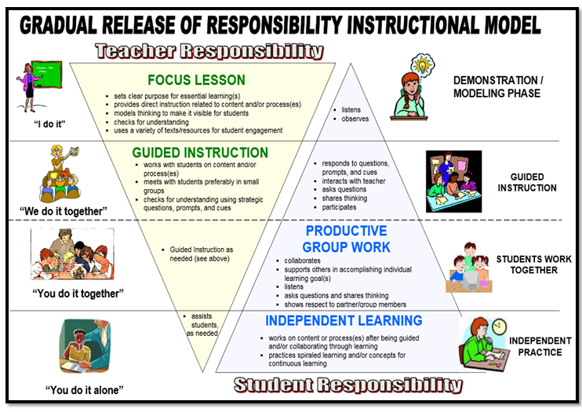

Parent/Student Acknowledgement

Syllabus Acknowledgement
This acknowledgement form and contact information sheet must be completely filled out, signed, and returned to the teacher. The student should then keep the syllabus in their binder for reference and documentation.

We acknowledge our responsibility to review this course syllabus.

We acknowledge that we have read, understood, and the student will comply with the expectations and guidelines presented in the course syllabus.

Student’s Name:
(Please Print)

Student’s Signature Date Parent/Legal Guardian Signature Date

Parent/Guardian Contact Information

Student’s Name:
Parent/Guardian’s Printed Name:
Parent/Guardian’s Email Address:
Home Number: | (_______) ______-________ | Daytime Contact Number: | (_______) ____-________
Cell Number: | (_______) ______-________ | Other Contact Number: | (_______)_____-________

Notes/Comments for the Teacher (please use back of this page for more room):

