Date | Activities
Saturday, January 15
Monday, December 17  NO SCHOOL | Track and Field-ALL TEAMS-Southwest HS
Tuesday, December 18  B Day  Leadership Meeting-7:45 AM  Admin Meeting-4:30 PM | Lady Mustang Basketball Vs Brackenridge  9th-6:15PM JV-7:30PM @Jefferson HS  Varsity-5:00 PM @LAC  Mustang Basketball Vs Brackenridge  9th(A)-7:30PM 9th(B)-6:15PM JV-5 PM @Brackenridge HS  Varisty-8 PM @LAC  Lady Mustang Soccer Vs Memorial  JV-7PM Varsity-5:30 PM @Edgewood  Spirit Parent Meeting-6PM @SUB
Wednesday, December 19  A Day  Faculty Meeting-AM/PM | Family Engagement-6PM @SUB/Cafeteria
Thursday, December 20
B Day
Friday, December 21  A Day | Lady Mustang Basketball Vs Highlands  9th-5PM JV-6:15 PM @Highlands HS  Varsity- 5PM @ACC  Mustang Basketball Vs Highlands  9th(A)-7:30 PM 9th(B)-6:15 PM JV-5PM @Jefferson HS  Varsity-6:30PM @ACC  Lady Mustang Soccer Vs Brackenridge  Varsity-7:30 PM @SC#1
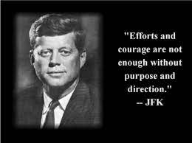 | Patrick Brennan-January 16  Luis Lopez-January 20

