Date | Activities
Saturday, May 21
Monday, May 23  A DAY | Final Exams-(1st/2nd period)-Seniors  Come get the scoop-6PM @SUB
Tuesday, May 24  B DAY | Final Exam-(5th/6th period)-Seniors
Wednesday, May 25  A DAY | Final Exams-(3rd/4th period)-Seniors  Chuckwagon-5PM/Jeff on parade-6:30 PM
Thursday, May 26  B DAY | Senior Meeting-8:30 AM @Auditorium  Graduate Walk-9AM (Jefferson Hallways)  Graduation Practice-11AM @ACC  AVID Ceremony-5PM @SUB
Friday, May 27 | Final Exams-(7th/8th period)  Senior Vaccination Clinic-2PM @SUB  Band social-6PM @Fountain Courtyard  Admin Meeting-3:50 PM @Library
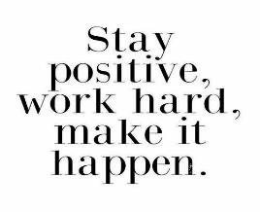 | 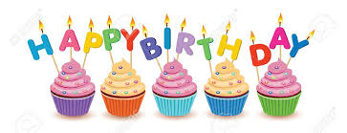  Tabitha Campbell-May 22

