HOW TO ACCESS MY CHILD’S SCORE

Online STAAR and TELPAS Scores
- Student Portal
How can I access my child's state assessment scores score online?
  - Parents and students may access scores online through the student portal.
What is the Student Portal?
  - The Student Portal provides parents and students with online access to scores from the State of Texas Assessments of Academic Readiness (STAAR) as well as the Texas Assessment of Knowledge and Skills (TAKS), and the Texas English Language Proficiency Assessment System (TELPAS) assessments.
Specific Features of the Portal:
  - Viewing student assessment results over the course of a student’s academic career.
  - Comparing individual student STAAR assessment results to campus, district, and state averages.
  - Examining student performance on STAAR, including individual student scale scores and objective scores.
  - Examining TELPAS examinee proficiency ratings, comprehension scores and composite score/rating.
Access to the Student Portal
  - Click here to access to the Student Portal.
You will see a screen like this:

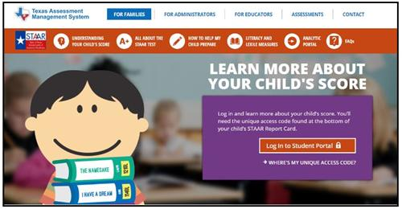
  - Select "Log in to Student Portal"
You will then see this screen:
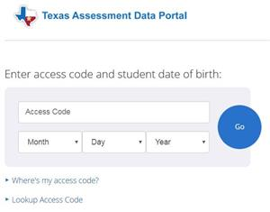
If you have your access code, enter the code and your child's birthdate to view scores.

If you do not have your access code, click on "Lookup Access Code" You will see this screen:
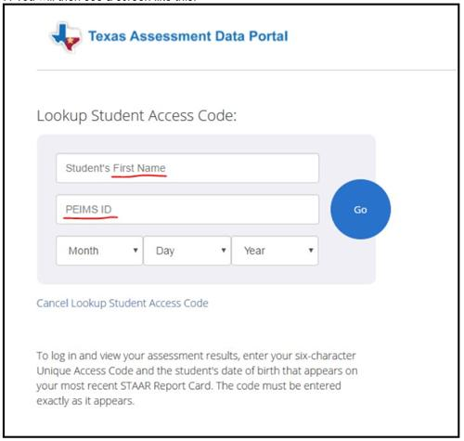

Enter your child's first name only and his or her social security number in the PEIMS ID field, and then your child's birthdate. Once the code appears, click "go."

Where do I find my child's unique access code?
  - The unique access code is also printed on all previous STAAR Student Report Cards. Once logged into the Student Portal, you will be able to examine test scores in detail.

