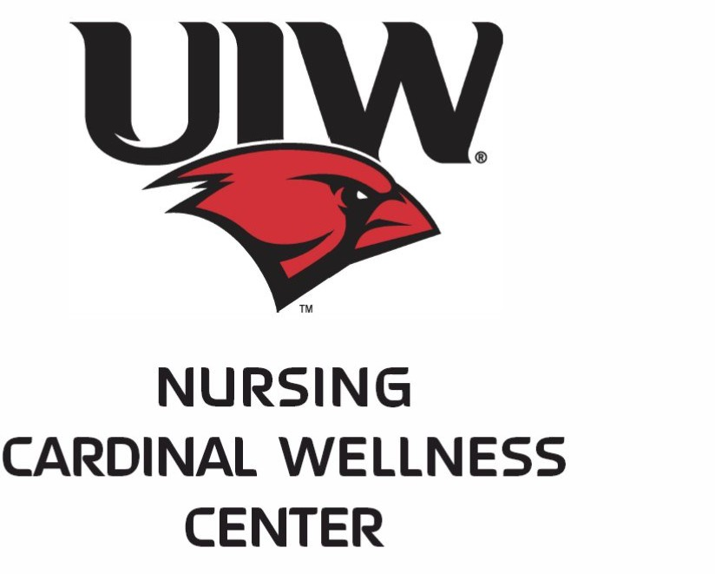

- School age children (4-18 years old): Eligibility
  - Medicaid/CHIP
  - Child does not have Health Insurance or Health Insurance does not pay for vaccine
  - Alaskan Native/Native American
- College Students (19 years and older)
  - Required college entrance Meningitis vaccine
  - Eligibility: No health insurance

BY APPOINTMENT ONLY
Saturday, August 22 and August 29
UIW School of Medicine – 7615 Kennedy Hill 78235
No fees charged

You must register and complete the required forms at
https://www.uiw.edu/ncwc/back-to-school-vaccines.html
https://uiwcardinalclinic.youcanbook.me/
Select the Cardinal Clinic at Brooks City Base
After appointment selected, click on forms (bottom of page) & complete
Contact: 210-283-6331 (leave a message)

