Lamar Newsletter
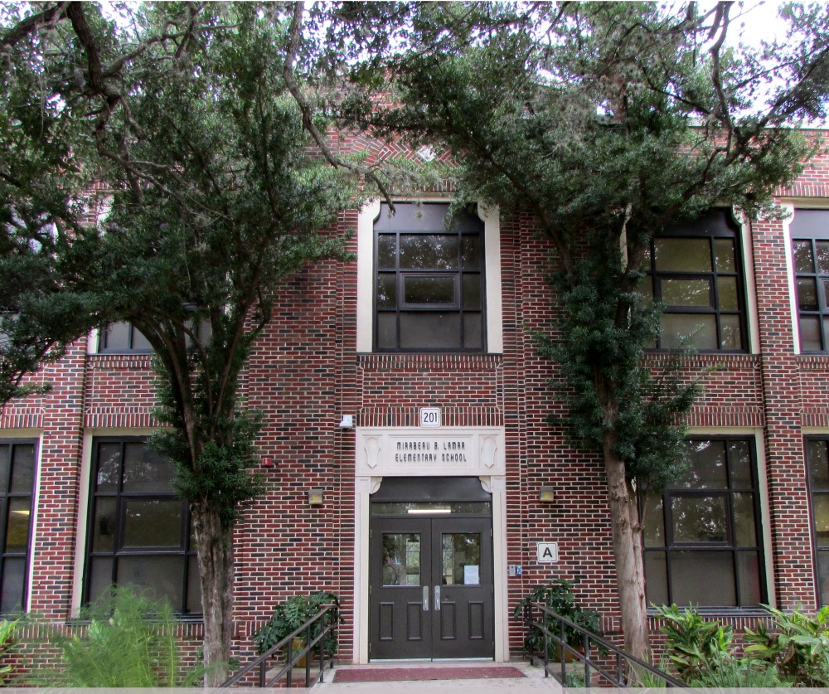

Upcoming events
January 17
Family Engagement Study Group,
5:00-6:00 PM, Art room

January 22
Raising Emotionally Healthy
Children Workshop, 3:45 PM or
5:00 PM

January 24
Prospective Family Info Session,
4:30 PM

January 24
V. Martinez Heritage Presentation,
5:30-7:00 PM in the library

January 26
Community Coffee Chat,
8:00-9:15 AM

What’s Happening at Lamar Elementary?
Mirabeau B. Lamar Elementary
201 Parland Place, San Antonio, TX 78209
www.saisd.net/schools/lamar146
Telephone: 210-738-9800

Important Announcements:

- Lamar students got off to a wonderful start in the new year! They were focused and ready to get back to learning. It was also great to hear their adventures from the holiday break!
- If you know of someone interested in our school, Lamar is hosting our final informational session on January 24 from 4:30-5:30 PM. Private tours can also be scheduled by calling the front office.
- Lamar is currently accepting applications for new students next year. Interested families should apply online by January 31 at the link on our school’s webpage, www.saisd.net/enroll
- Current Lamar families will submit an intent to return form in the spring starting in February. We will share that information via this newsletter and other communication forums.

Our Community
PTA President Monica Orozco is up at the school nearly every day working with families on how to make our school even greater. Stop by our Friday morning coffee chats starting as early as 7:30 AM in Ms. Sordo’s room. Keep your eyes and ears open for communication about getting dads and male figures more involved in our school. Finally, all families are invited to our Family Engagement Study Group that is helping to frame our future directions for how we build out our family engagement and involvement.

Principal Message
This past week was some of the best learning and behavior we have enjoyed this year. It was inspiring and really encouraging to see our kids come back fired up to learn in the new year.
I can’t wait to see what our kids produce this Spring!

Please be aware that we will not have school the week of February 5-9. We will have camps offered at a cost of $50 per student for the week of programming. Look for registration to open the week of January 22. Thank you all!

Brian Sparks, Lamar Elementary Principal

