Lamar Newsletter
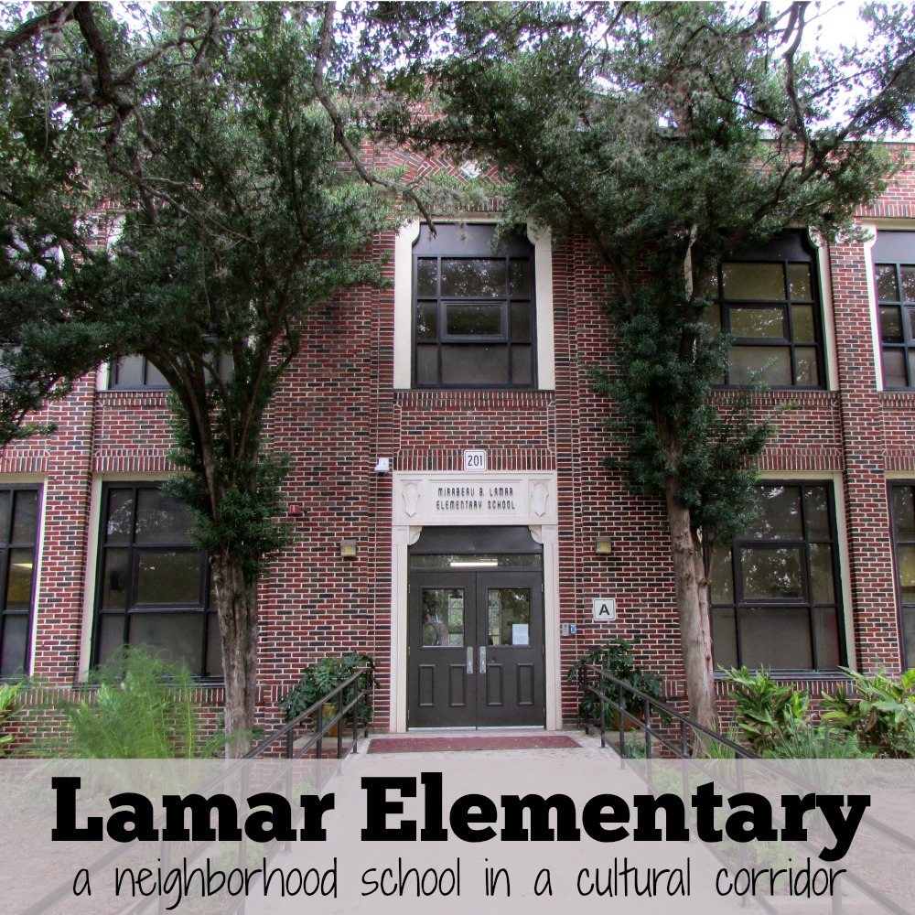

Upcoming events
December 8
Santa pictures (optional)

December 8
Lamar movie night, 6 PM

December 11-15
Book Fair

December 12
PK and Kinder performance, 6 PM

December 13
Lamar Informational Session for
new families, 4:30-5:30 PM

December 15
Community Coffee Chat, 8:15 AM
Bring a holiday dish to share

What’s Happening at Lamar Elementary?
Mirabeau B. Lamar Elementary
201 Parland Place, San Antonio, TX 78209
www.saisd.net/schools/lamar146
Telephone: 210-738-9800

Important Announcements:

- Congratulations to Monica Orozco on her new position as Lamar PTA President! We had over 70 PTA members vote at our election. Thank you all for supporting our campus.
- Lamar is currently accepting applications for new students next year. Interested families should apply online at the link on our school’s webpage, www.saisd.net/enroll
- Winter Break this year runs from December 22 – January 7. Lamar students start back on January 8 which is different from other SAISD schools.
- Winter parties will be held on December 21 starting about 2 PM. Families are welcome to attend. Contact your child’s teacher for more information.

Our Community
One of the goals of our growing PTA is to build a community among our families. Our families come from very close and far away to attend our school and building connections is critical to our success. Every Thursday, any Lamar family is invited to stay after school for a play group on our playground. Every Friday morning, every family is invited to join our Parent and Family Liaison, Ms. Sordo, and other families for coffee and conversation in the Curiosity Corner room. Thank you for continuing to be an active member of our school community.

Principal Message
We are not to the midpoint of this school year and we are already planning for the 18-19 school year. Below is some information that is pertinent to application and registration.
- Thank you to those of you who submitted sibling intent to enroll forms. If you missed this deadline, you may still apply now during the general application process.
- New students should apply at www.saisd.net/enroll. The window is currently open and closes on January 31.
- Returning students will submit an intent to return form in the spring.

Communication updates will go out through this newsletter. Many of you have expressed that you would like more frequent updates on information. This newsletter will be posted on our website, emailed to all families with emails on file in the office and linked to our school website.

I wish you all a happy holiday season. Thank you for continuing to grow Lamar into one of best schools in San Antonio.

