Course Names: | ENGLISH II,  ENGLISH II Pre-AP, | Teacher: | Mrs. G. Robles
Year: | 2018-2019 | Email: | grobles3@saisd.net
Course Credit: | 1 CREDIT | Room: | 618
Grade: | 10 | Conference: | 1st period (A Days,8:45-10:15)

Course Description http://tea.texas.gov/curriculum/teks/
The English Language Arts and Reading Texas Essential Knowledge and Skills (TEKS) are organized into the following strands: Reading, where students read and understand a wide variety of literary and informational texts; Writing, where students compose a variety of written texts with a clear controlling idea, coherent organization, and sufficient detail; Research, where students are expected to know how to locate a range of relevant sources and evaluate, synthesize, and present ideas and information; Listening and Speaking, where students listen and respond to the ideas of others while contributing their own ideas in conversations and in groups; and Oral and Written Conventions, where students learn how to use the oral and written conventions of the English language in speaking and writing. The standards are cumulative--students will continue to address earlier standards as needed while they attend to standards for their grade. Students should read and write on a daily basis.

Course Materials
English II General: Prentice Hall Literature and Writing Coach 10th grade
English II Pre-AP & General: Level 5 Springboard, various novels, laptops
All supplies are available at each student center in the classroom

*Occasionally, non-standard supplies will be required to complete student project deliverables (e.g. poster board, colored paper, etc.).

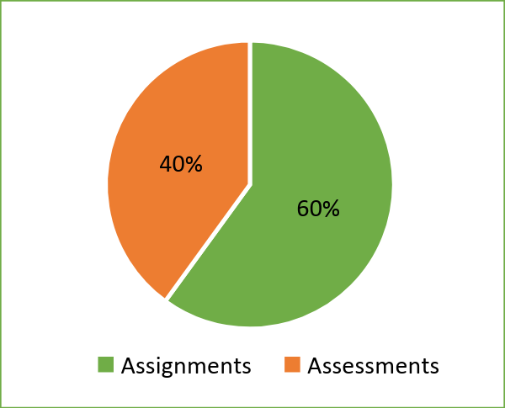
Grading Policy & Scale

Students’ grades will be calculated as follows:
- Assessment Performance (40%)
- Class Work & Homework Performance (60%)
The following grade scale will be utilized for recording students’ grades:
A | 90-100
B | 80-89
C | 75-79
D | 70-74
F | 0-69
In addition to progress reports every three weeks, parents and students have access to iData to monitor grades, assignments, and attendance. Ultimately, students are responsible for their own grades and attendance.

Class Expectations
All students must follow the student code of conduct as well as classroom and PBIS Behaviors:
- Be in appropriate school uniform
- Be on time and seated before the tardy bell rings
- Be prepared to learn with heads up and supplies ready
- Use appropriate language at all times
- Respect others and others’ property
- Cell phones can be put in the phone tree for extra credit and are otherwise not to be seen or used in class.
- Earbuds should only be in use when student is working on independent activities requiring audio support.

Classroom Management System
PBIS: Positive Behavior Intervention is a proactive and positive classroom management plan that will assist students as they transition through daily class activities by providing specific instruction on expectations. Expectations will be created with students and posted as our Treatment Agreement.

Consequences
Students who do not comply with the Hurricane Rules will receive consequences that include, but are not limited to, the following (in no specific order):

- Student/Teacher Conference
- Parent Contact
- Parent/Teacher Conference
- Counselor Support
- Discipline Referral
- Suspension and possible removal from Pre-AP program

Make-Up Work & Re-Do Policy
The curriculum syllabus and weekly lesson plans will be posted on our Google Classroom Page
(https://classroom.google.com ) as well as on my teacher webpage (https://schools.saisd.net/page/grobles3-Home ).

Students and parents will have their own user accounts to be able to access the content on iData Make up work and work needing to be reworked will be visible in iData. In addition, students may see me during my tutorial times. Detailed District Policy over make-up work and reworked assignments is clearly outlined in the Student Handbook.

Computer Usage
Computers are to be used for educational purposes only. By touching the computers, students agree to follow the SAISD Student Acceptable Use Policy for the Electronic Communications Systems.

COLOSO Learning Objectives and Gradual Release of Responsibility Instructional Model (daily grade)
COLOSO: ESC 20 has implemented a structure for daily content, language and social objectives (COLOSO). This structure provides students with a clear focus for daily classroom instruction.
- Content Objective: tells what students will learn during the lesson.
  - Example: “Students will reanalyze archetypes in mythic, traditional, and classic literature.” TEK 2b
- Language Objective: tells how the students will learn and/or demonstrate their mastery of the lesson by reading, speaking, writing, or listening.
  - Example: “Students will use interactive notebooks to enhance understanding of key vocabulary and examples.
- Social Objective: tells what students will do as a physical activity. This includes interacting with others within the classroom.
  - Example: “Students will work in pairs and small groups to read common texts and identify archetypes.
Gradual Release of Responsibility (GRR): GRR is how learning will look in the classroom.
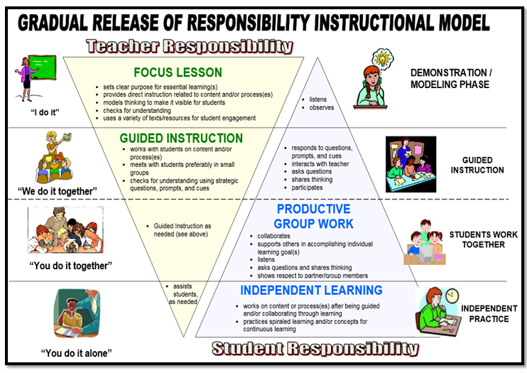

Parent/Student Acknowledgement

Course Names: | ENGLISH II,  ENGLISH II Pre-AP, | Teacher: | Mrs. G. Robles
Year: | 2018-2019 | Email: | grobles3@saisd.net
Course Credit: | 1 CREDIT | Room: | 618
Grade: | 10 | Conference: | 1st period (A Days,8:45-10:15)

Syllabus Acknowledgement
This acknowledgement form and contact information sheet must be completely filled out, signed, and returned to the teacher. The student should then keep the syllabus in their binder for reference and documentation.

We acknowledge our responsibility to review this course syllabus.

We acknowledge that we have read, understood, and the student will comply with the expectations and guidelines presented in the course syllabus.

__________________________________ __________________________________
Student’s Signature Parent/Legal Guardian Signature Date

Notes/Comments for the Teacher (preferential seating, special concerns/considerations, etc.):

